1. Design an App for Textile company, when the user selects the type of material and the length of the cloth needed, compute the bill. Cotton 1 meter costs 500rs, spun 100rs and linen 1000rs. Write the Java code of the MainActivity.java and XML

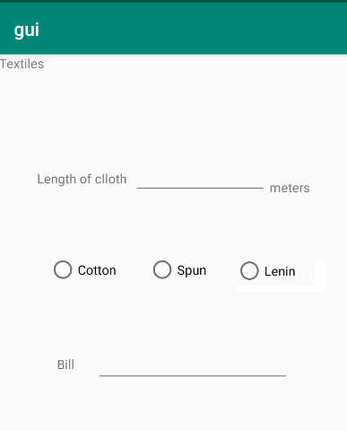

2. Design the Sounding App. When a particular image button is clicked that sound (assume sounds are in uri’s) needs to be played. (only one sound should play when clicked successively). Write the Java code alone.

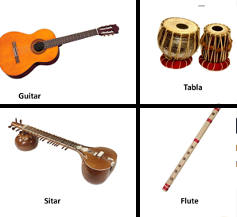

3. Create an Activity which performs the following actions when the activity changes its state.

On start app has background black and img1 (as shown in figure 1). Onpause set background yellow and img2 (figure 2), OnRestart() white background with img3.(java code)

 

4.Design an App that sends an array of 10 elements from MainActivity to secondActivity which reads the array elements and finds the sum of these elements and return the sum of results to mainActivity.

5.Design the below layout. Image followed by two buttons, Image followed by two buttons, Image followed by two buttons and an Image.

